Date: 20th Aug 21’

**Problem Statement:** Write a program to find occurrence of any specific word.

**Input File:**

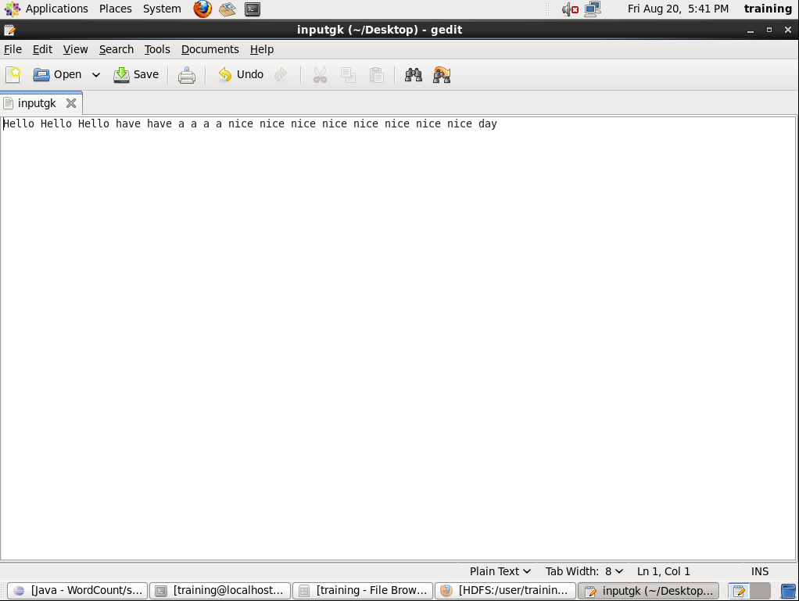

Map Reduce Code:

import java.io.IOException;

import java.util.*;

import org.apache.hadoop.fs.Path;

//import org.apache.hadoop.conf.*;

import org.apache.hadoop.io.*;

import org.apache.hadoop.mapred.*;

//import org.apache.hadoop.util.*;

public class WordCount {

public static class Map extends MapReduceBase implements Mapper<LongWritable, Text, Text, IntWritable> {

private final static IntWritable one = new IntWritable(1);

private Text word = new Text();

String find = "Hello";

public void map(LongWritable key, Text value, OutputCollector<Text, IntWritable> output, Reporter reporter) throws IOException {

String line = value.toString();

String temp = "";

StringTokenizer tokenizer = new StringTokenizer(line);

while (tokenizer.hasMoreTokens()) {

temp = tokenizer.nextToken();

if(temp.equals(find)){

word.set(temp);

output.collect(word, one);

}

}

}

}

public static class Reduce extends MapReduceBase implements Reducer<Text, IntWritable, Text, IntWritable> {

public void reduce(Text key, Iterator<IntWritable> values, OutputCollector<Text, IntWritable> output, Reporter reporter) throws IOException {

int sum = 0;

while (values.hasNext()) {

sum += values.next().get(); }

output.collect(key, new IntWritable(sum));

} }

public static void main(String[] args) throws Exception {

JobConf conf = new JobConf(WordCount.class);

conf.setJobName("wordcount");

conf.setOutputKeyClass(Text.class);

conf.setOutputValueClass(IntWritable.class);

conf.setMapperClass(Map.class);

conf.setCombinerClass(Reduce.class);

conf.setReducerClass(Reduce.class);

conf.setInputFormat(TextInputFormat.class);

conf.setOutputFormat(TextOutputFormat.class);

FileInputFormat.setInputPaths(conf, new Path(args[0]));

FileOutputFormat.setOutputPath(conf, new Path(args[1]));

JobClient.runJob(conf);

} }

**Code Execution:**

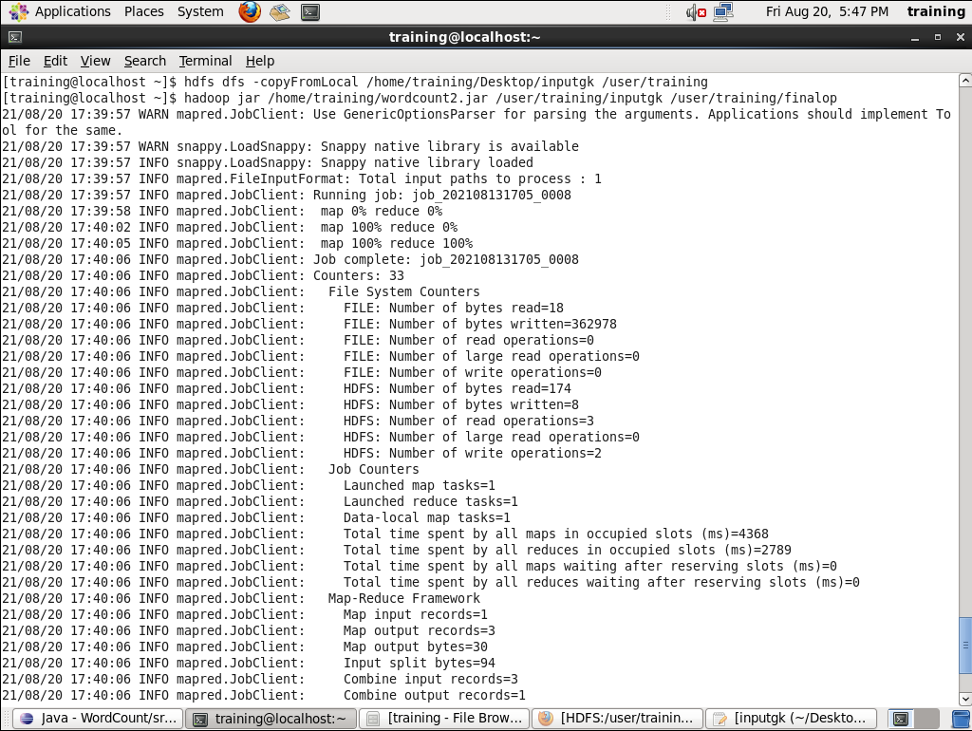

**Output File:**

